Introduction

The Conservation Commission is a 7-member municipal board responsible for administering the Massachusetts Wetlands Protection Act (M.G.L. c. 131, § 40), the Massachusetts Wetlands Regulations (310 CMR 10.00), and the City of Westfield Wetlands Protection Ordinance (NO. 1738).

Under these laws and regulations, the Commission has jurisdiction over the following areas (Jurisdictional Areas):

- Wetland Resource Areas which includes wetlands, 100-year flood zones, vernal pools, ponds, marshes, lakes, streams, rivers and creek;
- Riverfront Areas defined as land within 200 feet of a perennial stream; and
- Buffer Zones defined as land within 100 feet of a Wetland Resource Area.

The City of Westfield Wetlands Ordinance 1738 prohibits work within 50ft of a wetland.

Any work in a wetland, within the 100-year floodplain, 100 feet of a wetland, or within 200 feet of a stream or river, such as vegetation or vegetation removal or clearing, filling or depositing of soils, grading, excavation or paving, new landscaping or construction, additions, etc. or any other activity that might alter wetlands or their buffer zones, you are required by state and municipal laws to contact your local Conservation Commission at (413) 572-6281 to discuss the proposed work and permitting process.

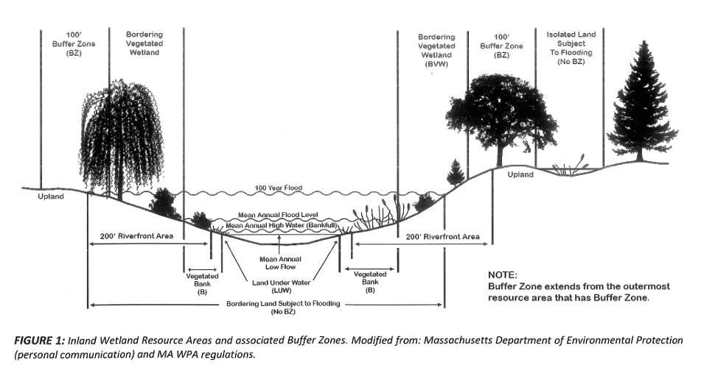
Purpose
This Document Serves To:
- Protect the interests of the Act;
- Recognize and protect the above ecological functions within Jurisdictional Areas;
- Provide clear and consistent guidelines for enforcement issues; and
- Allow land owners to maintain safety and enjoyment of land, while also providing and maintaining important ecological functions in wetlands.

Areas subject to protection (wetlands) are regulated in order to contribute to the following interests and concerns of the Massachusetts Wetlands Protection Act, its regulations (310 CMR 10.00), and Westfield Wetlands Protection Ordinance, those interests being:
- Protection of public and private water supply | - Protection of ground water supply
- Storm damage prevention | - Prevention of pollution
- Protection of land containing shellfish | - Protection of fisheries
- Protection of wildlife habitat | - Flood control
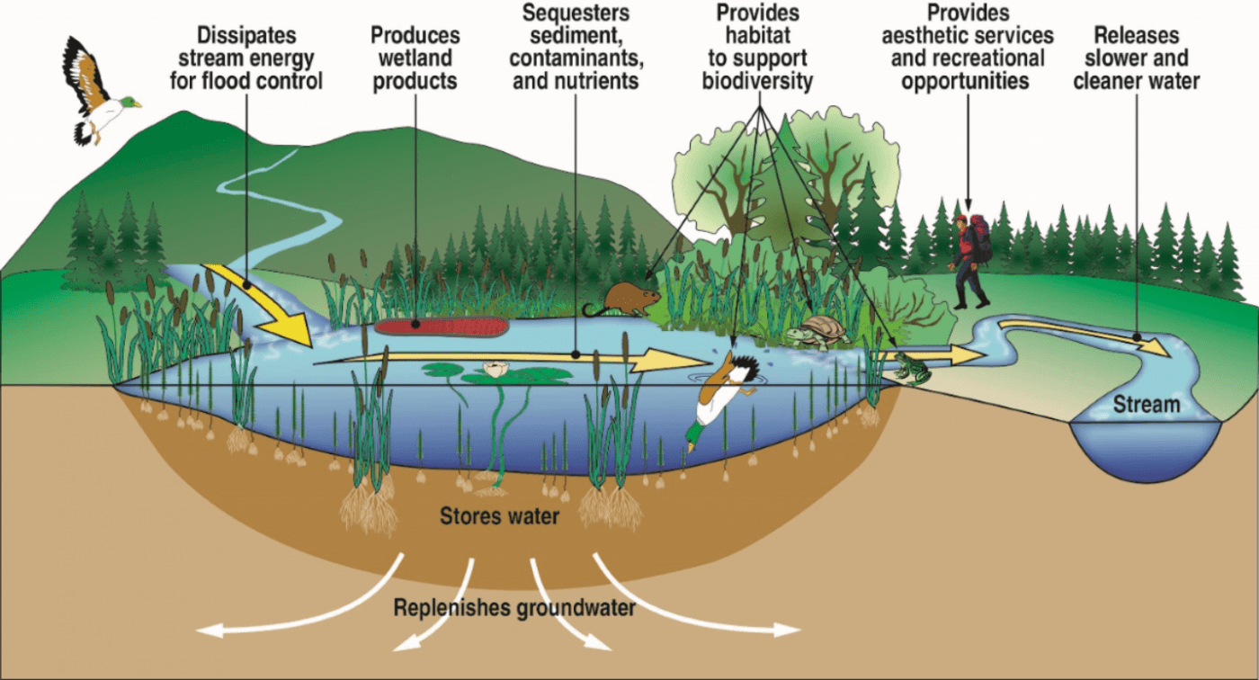

Diagram from Booth and Shock (2016) Environmental Perspectives Vol. 3.

The Commission presumes that removal of vegetation and vegetation in jurisdictional areas will have a negative impact on the interests listed above. The Commission also presumes restoration of the 50’ buffer zone of native vegetation will contribute to the protection of those interests (Section 13-63 of the ordinance). In addition, maintaining vegetation and vegetation in and near wetlands serves a wide variety of functions, including but not limited to:

- Prevention of soil erosion and property damage by reducing storm run-off;
- Increase in biodiversity;
- Performing ecological functions by providing habitat for a variety of wildlife;
- Assisting nutrient uptake and improving water quality;
- Providing shade and evaporative cooling through transpiration;
- Regulating weather/climate (temperatures, precipitation patterns); and
- Improving local and global air quality by absorbing carbon dioxide and ozone, absorbing particulate matter, and producing oxygen.
Unpermitted Vegetation Removal

No vegetations may be cut from Jurisdictional Areas unless permission has been granted by the Commission and such policy applies to all Areas, whether natural or landscaped.

The Commission may permit vegetation cutting under the following guiding principles, provided the landowner has filed a Request for Determination of Applicability or a Notice of Intent as appropriate for the proposed project.

- To be approved for removal, the vegetation(s) must either:
  - Pose a safety threat, or
  - Prevent substantial use of the landowner’s property
- Conditions for removal
  - Mitigation: Some vegetation cutting requests may be granted with conditions concerning the replacement of one or more vegetation
  - Limited use of equipment: In many cases, the Commission requires that vegetation removal equipment remain outside the natural areas
  - Limited grinding/removal of trunks: In order to minimize disturbance, the Commission may require no removal of trunks (and roots) or limit grinding of trunks to those areas outside the 50 foot no disturb zone
- In area where work is to occur, existing vegetation shall be protected with fencing or other measures to provide a maximized area of undisturbed root zone during construction.
- If site work results in the death or significant decline of a vegetation that was intended to remain, the below vegetation replacement requirements shall apply.

In the event that unpermitted vegetation removal occurs, the Commission may issue an Enforcement Order requiring a replanting/replacement plan as described below.

The applicant, landowner, or consultant shall submit information such as:

- Replacement plant species list;
- Plans/sketch/map/photos showing locations of removed vegetation and their replacements; and
- Any additional information the Commission deems necessary which may include but is not limited to:
  - Extent of area of disturbance (square feet);
  - Type of area of disturbance (wetland type);
  - Slope steepness and elevations;
  - Solar radiation and slope aspect;
  - Types of vegetation removed;
  - Amount of vegetation vs. shrubs removed;
  - Soil disturbance (stumping); and
  - Soil stabilization.

Vegetation Replacement Requirements and Conditions

Should the Policy apply, the following replacement ratios will be considered by the Commission:
Ground and Herbaceous Layer | Disturbed ground and herbaceous layers will be revegetated with a wetland seed mix
Shrub Layer | For every 2 shrubs removed, 1 shrub will be planted (2:1)
Tree Layer | - For every 1 tree removed measuring greater than 4” at DBH*, 3 trees shall be planted (1:3)  For every 1 trees removed measuring less than 4” DBH, but greater than 1” DBH, 2 trees shall be planted (2:1) OR 2 shrubs
*DBH – diameter at breast height of a tree

- Replacements shall be native, of the same species removed, or other viable alternatives
  - A list of appropriate species can be found in: National List of Plant Species That Occur in Wetlands: Massachusetts (Fish & Wildlife Service, U.S. Department of the Interior, 1988); or;
  - Conservation Commission’s Website
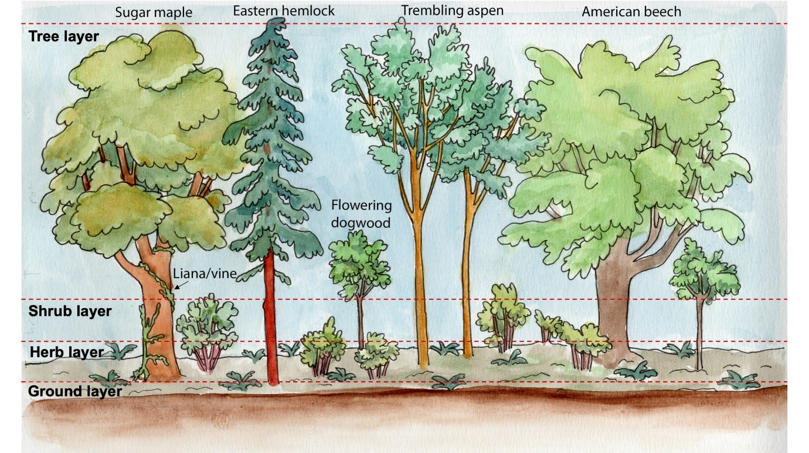
- Replacements shall be in the same location, or as close as possible;
(Artwork by Sara Hewitt-Wood; licensed under CC BY-NC-ND 4.0)
- Species must provide biodiversity and wildlife habitat;
- Replacements grow to a size equivalent to or greater than the vegetation(s) removed;
- Replacements should meet the current “American Standard for Nursery Stock” (ANSI Z60.1) and be a minimum size of 1-inch caliper for vegetations or 2-gallon container for shrubs or such size that is acceptable to the Commission;
- Post planting, all soils shall be stabilized in a manner appropriate for the site (loam & seeded, straw matting, erosion controls etc.);
- In areas where work is to occur, existing vegetations shall be protected with fencing or other measures to provide a maximized area of undisturbed root zone during construction;
- At least 75% of replacements must survive two growing seasons (April 1st – October 31st) and failed plants shall be replaced; and
- The site will be monitored for growth of invasive species and such species removed immediately

Discretion

The Commission understands that every project is different. As such, the Commission can exercise discretion in the application of this policy when space is limited on site or there exist other unique site constraints. An applicant or landowner may request mitigation in lieu of compliance, or a policy waiver, both in writing to the Commission. The request should include reasons for the inability for compliance such as:

- Vegetation(s) were damaged due to a storm event; or
- The property is heavily wooded and new growth would be difficult or unnecessary; or
- There is no available space to replant vegetations or shrubs.

The Commission may also use their discretion to require any combination of replacement sizes and locations as they deem reasonable.

